Preliminary, January 29, 2022
A Quantile Study of Two Covid-19 Years: Accounting for Countries’ Heterogeneity
by
Joshua Aizenman, Alex Cukierman, Yothin Jinjarak, Sameer Nair-Desai, and Weining Xin

This paper takes stock of the remarkable heterogeneity of countries’ Covid-19 experience during the first two Covid years, 2020-2021. This heterogeneity is illustrated by Figure 1, reporting cumulative confirmed Covid-19 death per-million, for high, upper-middle, lower-middle, and low income, and the World.
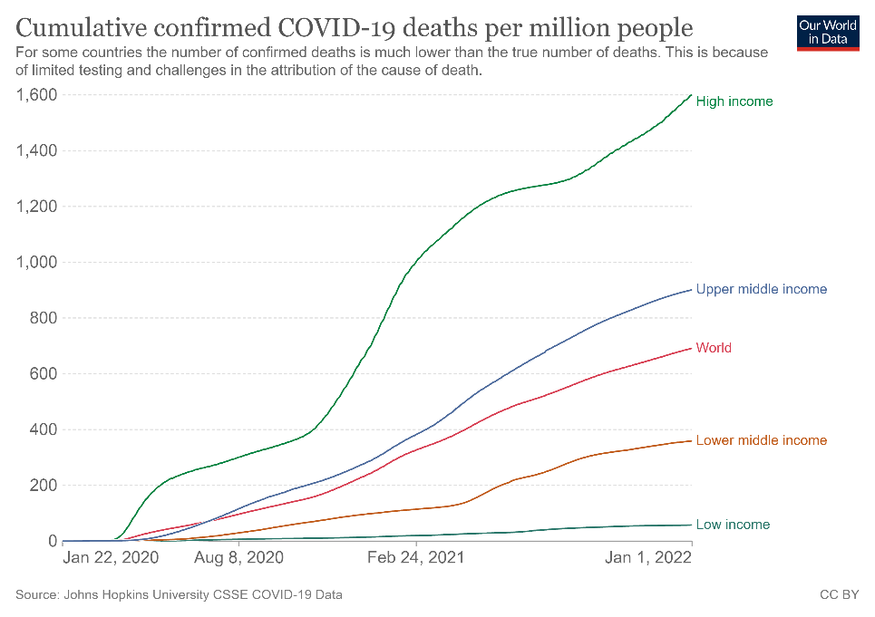
Figure 1: Cumulative confirmed Covid-19 death per-million, high, upper-middle, lower-middle, low income, and the world, 2020-2021.

At first glance, one may conclude that higher income countries experienced a much worse pandemic. However, it has been widely discussed how the officially reported mortality may not reflect the true death tolls by the pandemic, and the degree of the limitations of official statistics vary across the globe. For example, countries may be different in testing availability and definitions of ‘Covid-19’ deaths. To gain further insight on data limitations associated with confirmed (i.e., officially reported) Covid-19 counts, we evaluate the quartile ranking of countries using both confirmed Covid-19 and excess mortality data. Contrasting countries ranking using these two data sources reveals sharp and systematic contrasts in raking. While higher GDP per capita is associated with worse mortality ranking using the confirmed Covid-19 mortality data, there is no such an association in the excess mortality data. Similar observations apply to other variables.
In order to gain further insight, we run regressions accounting the ratio of Cumulative Excess/Official COVID-19 mortality ratios across countries. We do it for two dates; the end of 2020, contrasting it to the end 2021, controlling for GDP/Capita and vaccination rates for 170 countries. Notably, we find that by the December 2021, Cumulative Excess/Official COVID-19 mortality ratios are smaller for countries with higher GDP/Capita and higher vaccination rates. Yet, there is no such an association by the end of 2020. This suggests that the arrival of vaccinations in early 2021 was a game- changer. Next, we run regressions accounting for the Cumulative Excess/Official COVID-19 mortality ratio across countries with additional controls for the two dates, December 2020, and December 2021. For both samples, higher average and lower standard deviation of the stringency index is associated with lower Cumulative Excess/Official COVID-19 mortality ratios.
We close the analysis by contrasting the quartile rankings between the two data sets at the end of 2021. For 3/5 of the countries, their quartile ranking differs between the two data sets. Next, we contrast countries that are ranked substantially better to countries that are ranked substantially worse in excess mortality than in official Covid mortality count. On average, the ‘doing better’ countries in excess mortality than official count are characterized by lower population density; higher GDP/Capita; scoring better in rule of law, voice accountability, and government effectiveness; higher mean and lower standard deviation of stringency index; and substantially higher vaccination rates.
These results suggest that one should take the official confirmed Covid morality counting with a grain of salt, and one may supplement this information with excess mortality data. Vaccination rates, governance variable, and other structural variables explain the ranking gaps between the two data sets.

- Data
Our full dataset is constructed by supplementing the database on Covid-19 by Our World in Data with a few other datasets, including the Oxford’s Covid-19 Government Response Tracker, the World Development Indicator (WDI) database, the World Governance Indicator (WGI) database, and the Economist’s tracker for Covid-19 excess deaths. The full dataset covers 170 countries at weekly frequency from January 1, 2020 to December 31, 2021.
Specifically, from the Our World in Data’s Covid-19 database, we use cumulative officially reported Covid-19 mortality (per million population), total number of Covid-19 vaccination doses administered per 100 people in the toal population, population density, share of aged 65+ population, GDP per capita. We use the Government Response Strigency Index (SI) from the Oxford’s Covid-19 Government Response Tracker, which is a composite measure based on 9 indicators including school closures, workplace closures, and travel bans, rescaled to a value from 0 to 100 with 100 indicating the strictest response. We use the share of urban population from the WDI database, and rule of law, voice and accountability, and government effectiveness in the WGI database: rule of law captures perceptions of the extent to which agents have confidence in and abide by the rules of society, and in particular the quality of contract enforcement, property rights, the police, and the courts, as well as the likelihood of crime and violence; voice and accountability captures perceptions of the extent to which a country's citizens are able to participate in selecting their government, as well as freedom of expression, freedom of association, and a free media; and Government effectiveness captures perceptions of the quality of public services, the quality of the civil service and the degree of its independence from political pressures, the quality of policy formulation and implementation, and the credibility of the government's commitment to such policies.
We use cumulative excess mortality per million population from the Economist’s tracker for Covid-19 excess deaths, which is calculated by taking the motality from all causes in a given country and period, and then comparing it with a historical baseline from recent years. The modelled baselines fit a linear trend for year, accounting for long-term increases or decreases in mortality, and a fixed effect for each week or month up to February 2020.

- Quartile Evidence Contrasting Confirmed versus Excess Cumulative Covid Mortality, 2020-2021
We start by tabulating the quartile rank order of mortality per million during the first two Covid-19 years (from the beginning of 2020 to the end of 2021) using the two mortality measures, i.e., the confirmed (or official) mortality and the excess mortality. Next, we describe the large discrepancies of countries’ ranking between the two motality meauses. To gain further insight, we apply statistical analysis accounting these differences, and close with discussion and interpretations.
Table 1 reports the average statistics of countries in quartiles of the cumulative confirmed Covid mortality per million up to December 31, 2021. Table 2 reports the country list in each quartile. Table 3 and Table 4 reports the same information using the excess mortality data.
Table 1: Average Quartiles Statistics of Cumulative Confirmed Covid Mortality, December 31 2021
Variable | 1st Quartile (Lowest Cum. Mortality) | 2nd Quartile | 3rd Quartile | 4th Quartile (Highest Cum. Mortality)
Population | 66,246,385.5 | 72,137,531.6 | 27,555,946.7 | 37,762,631.6
Population Density | 278.6 | 390.4 | 185.7 | 89.9
Urban Population Share | 42.9 | 55.5 | 68.6 | 69.6
Aged 65+ Population Share | 4.1 | 6.7 | 9.1 | 14.6
GDP per Capita | 5310.4 | 20590.6 | 24297.7 | 22234.7
Rule of Law | -0.7 | -0.2 | 0.1 | 0.2
Voice and Accountability | -0.8 | -0.5 | 0 | 0.5
Government Effectiveness | -0.8 | -0.1 | 0.2 | 0.3

Table 2: Country List of Quartiles of Cumulative Confirmed Covid Mortality, December 31 2021
1st Quartile (Lowest Cum. Mortality) | 2nd Quartile | 3rd Quartile | 4th Quartile (Highest Cum. Mortality)
Burundi | Somalia | Morocco | Bolivia
China | Australia | Kyrgyz Republic | Panama
New Zealand | Timor-Leste | Philippines | Uruguay
Chad | Kenya | Indonesia | France
Niger | Rwanda | Denmark | Serbia
South Sudan | Korea | Kuwait | Portugal
Tanzania | Senegal | Belarus | Ecuador
Tajikistan | Malawi | El Salvador | Spain
Benin | Equatorial Guinea | Iraq | Greece
Congo, Democratic Republic of the | Gabon | Mongolia | Trinidad and Tobago
Nigeria | Pakistan | Sri Lanka | Chile
Burkina Faso | Gambia, The | Oman | Russia
Sierra Leone | Algeria | Canada | Tunisia
Eritrea | Japan | Bahrain | United Kingdom
Central African Republic | Singapore | Azerbaijan | Italy
Côte d'Ivoire | Syria | Libya | Mexico
Hong Kong SAR | Bangladesh | Jamaica | Paraguay
Guinea | Cambodia | Guatemala | Ukraine
Togo | Mauritania | Israel | Moldova
Mali | Afghanistan | Malaysia | Latvia
Nicaragua | Venezuela | Kazakhstan | Belgium
Taiwan Province of China | Mauritius | Turkey | United States
Madagascar | Djibouti | Botswana | Poland
Ghana | Zambia | Honduras | Colombia
Uzbekistan | Egypt | Swaziland | Argentina
Lao P.D.R. | Qatar | Albania | Slovenia
Angola | United Arab Emirates | Ireland | Armenia
Liberia | Norway | Jordan | Lithuania
Ethiopia | Saudi Arabia | Netherlands | Brazil
Mozambique | Finland | Germany | Slovak Republic
Papua New Guinea | Lesotho | Lebanon | Croatia
Congo, Republic of | Thailand | Switzerland | Romania
Yemen | Vietnam | Namibia | Czech Republic
Haiti | Zimbabwe | Costa Rica | Georgia
Cameroon | India | Estonia | Macedonia, FYR
Uganda | Myanmar | Sweden | Hungary
Sudan | Dominican Republic | Austria | Bosnia and Herzegovina
Guinea-Bissau | Nepal | South Africa | Bulgaria
 |  | Iran | Peru

Table 3: Average Statistics of Excess Mortality/Millions of Countries in Quartile, December 31, 2021
Variable | 1st Quartile (Lowest Cum. Mortality) | 2nd Quartile | 3rd Quartile | 4th Quartile (Highest Cum. Mortality)
Population | 55,790,460.9 | 36,315,592.6 | 42,391,243.5 | 68,018,586.5
Population Density | 530.1 | 122.2 | 182.7 | 116.7
Urban Population Share | 63.3 | 48.4 | 66 | 60.2
Aged 65+ Population Share | 8.8 | 6.2 | 9.1 | 10.7
GDP per Capita | 25293 | 11369.8 | 20820.5 | 15622.5
Rule of Law | 0.3 | -0.5 | -0.1 | -0.3
Voice and Accountability | 0.1 | -0.5 | -0.1 | -0.3
Government Effectiveness | 0.3 | -0.4 | 0 | -0.2

Table 4: Average Statistics of countries in Excess mortality/million quartiles, mortality/million December 31, 2021
1st Quartile (Lowest Cum. Mortality) | 2nd Quartile | 3rd Quartile | 4th Quartile (Highest Cum. Mortality)
New Zealand | Equatorial Guinea | Netherlands | Pakistan
Sierra Leone | Niger | Chile | Nepal
Taiwan Province of China | Nigeria | Bahrain | India
Benin | Sweden | Yemen | Bangladesh
Mauritius | Tanzania | Philippines | Swaziland
Australia | Algeria | Belgium | Nicaragua
Liberia | Uganda | Rwanda | Ecuador
Korea | Zambia | Lebanon | Libya
Madagascar | Angola | United Arab Emirates | Czech Republic
Japan | Togo | Kyrgyz Republic | Sudan
Singapore | Uzbekistan | Morocco | South Africa
Hong Kong SAR | Costa Rica | Greece | Azerbaijan
Ghana | Germany | Myanmar | Hungary
Papua New Guinea | Guinea | Venezuela | Djibouti
Central African Republic | Guinea-Bissau | United Kingdom | Latvia
Malaysia | Cambodia | Congo, Republic of | Moldova
Senegal | France | South Sudan | Turkey
Qatar | Haiti | Portugal | Kazakhstan
Malawi | Jamaica | Tunisia | Poland
Eritrea | Switzerland | Trinidad and Tobago | Croatia
Mongolia | Vietnam | Spain | Bolivia
Norway | Burundi | Slovenia | Ukraine
Denmark | Gambia, The | Paraguay | Slovak Republic
Timor-Leste | Lao P.D.R. | Guatemala | Honduras
China | Tajikistan | Estonia | Georgia
Canada | Gabon | Zimbabwe | Albania
Mali | Somalia | Indonesia | Mexico
Lesotho | Sri Lanka | Jordan | Saudi Arabia
Côte d'Ivoire | Mozambique | El Salvador | Armenia
Ireland | Mauritania | Italy | Romania
Dominican Republic | Congo, Democratic Republic of the | Iran | Iraq
Burkina Faso | Kenya | Egypt | Bosnia and Herzegovina
Finland | Cameroon | United States | Belarus
Israel | Chad | Botswana | Peru
Syria | Afghanistan | Brazil | Lithuania
Oman | Panama | Argentina | Macedonia, FYR
Thailand | Austria | Kuwait | Russia
Uruguay | Ethiopia | Colombia | Serbia
 |  | Namibia | Bulgaria

Contrasting the average statistics in each quartile of cumulative confirmed Covid mortality per million up to December 2021 (Table 1) with those in the same quartile of cumulative excess mortality per million in December 2021 (Table 3) revels disturbing fundamental differences between these two mortality measures and the resulted country quartile rankings.
Table 1, indicates that on average, higher GDP/capita countries preformed badly relative to the low- and middle-income countries in terms of the cumulative confirmed Covid mortality ranking. The lowest mortality quartile average GDP/capita is 1/4 of the higher mortality quartile. The second worst preforming quantile average GDP/Capita exceed the GDP/Capita of the second-best performing quantile by about 1/5. Similar observations apply for measures of institutional quality. The best preforming quartile average health expenditure was 1/8 of that of the worst preforming quartile; the rule of law, the voice and accountability, and government effectiveness are ranked significantly higher for the worst preforming quartile.
Intriguingly, almost the opposite patterns characterize the quartiles of cumulative excess mortality, reported in Table 3. The lowest excess mortality quantile average income/capita is the highest ($ 25,293), while the second-best preforming quartile has the lowest average income/capita, less than half of the best preforming quartile. The worst excess mortality quartile’s average income/capita is 3/5 of the average income/capita of the best preforming quartile. The quartile with the lowest excess mortality is also characterized by best rule of law, voice and accountability, and government effectiveness.
These observations raise fundamental concerns about the quality of confirmed (or official) cumulative mortality data in Covid-19 times. It also challenges simplistic interpretations and generalizations, like the notion that on average, OECD countries failed in dealing with Covid challenges relative to low- and middle-income countries. This view is in line with the quartiles’ average statistics of confirmed Covid mortality, but is mostly rejected by the excess mortality data. The sharp contrast between the two tables suggests that countries ranked higher in terms of rule of law, voice and accountability and government effectiveness are also countries where the gap between the confirmed covid mortality and the excess mortality is smaller.

- Statististical Analysis of the Gap between Confirmed and Excess Cumulative Covid Mortality, 2020-2021
In order to gain further insight on the gap between confirmed and excess cumularive Covid mortality, we run regressions accounting the ratio of Cumulative Excess/Official COVID-19 mortality ratios across countries. We do it for two dates; the end of 2020, contrasting it to the end 2021, controlling for GDP/Capita and vaccination rates for 170 countries.
Table 5 provides the estimation of cumulative excess/official COVID-19 death ratios (henceforth, E/O) on the level of income (as measured by GDP per capita) and the level of vaccination (the share of people (per hundred) fully vaccinated against COVID-19) across 170 countries for 2020 and 2021. The first column shows that, at the end of 2020, the association between E/O and GDP per capita is negative but statistically insignificant. In 2021, however, as the COVID-19 vaccines became widely available throughout the year for a large number of countries, the association between cumulative E/O and GDP per capita remains insignificant, but the association with the level of vaccination have become negative and statistically significant in the international sample. To put these numbers in context, given the distribution of GDP per capita, the results suggest that the income gap between the average countries at 75 percentile ($ 29.481 per capita; in thousand) and the average countries at 25 percentile ($ 4.227 per capita; in thousand) is associated with (29.481-4.227)*0.13 = 3.283 larger in the excess deaths to official mortality ratio (a mean of 15.085, a standard deviation of 47.350) of the lower-income countries. Further, the gap in vaccination between the average countries at 75 percentile (65.37 fully vaccinated per hundred people) and the average countries at 25 percentile (7.54 fully vaccinated per hundred people) is associated with (65.37-7.54)*0.42 = 24.28 larger in the excess deaths to official mortality ratio of the lower-vaccinated countries by the end of 2021.
Table 5. Regression of Cumulative Excess/Official COVID-19 Death Ratios across Countries, 2020 and 2021.
Dependent variable: Cumulative Excess/Official COVID-19 Death Ratios
 | As of 2020-12-28 | As of 2021-12-27
GDP per Capita | -1.34 | -0.13
 | (0.92) | (0.13)
Vaccination |  | -0.42*
 |  | (0.18)
Constant | 57.01 | 33.68***
 | (37.61) | (8.83)
F-stats | 2.1 | 6.3
R-squared | 0.01 | 0.09
Countries | 170 | 170
Note: Vaccination is the share of people (per hundred) fully vaccinated against COVID-19. Excess Deaths (per million population) are from the Economist; Official Deaths (per million population) from COVID-19 and Vaccination from Our World in Data. GDP per Capita (thousands) is based on purchasing power parity (PPP) International Comparison Program (ICP).
Robust standard errors are in parenthesis.
* p<0.05, ** p<0.01, *** p<0.001

Table 6 provides the estimation of E/O ratios on a larger set of variables, including the level and degree of stability of containment measures (as measured by the average and standard deviation of stringency index within the sample period), the vaccination campaign (as measure by the number of Covid-19 vaccinations administered per hundred population), a set of demographic variables including population density, urban population share, and aged 65+ population share, the level of income (as measured by GDP per capita), and a set of variables from World Governance Indicators database measuring the quality of governance including rule of law, voice and accountability, and government effectiveness. The samples cover about 140 countries for December 2020 and December 2021, and are determined by data availability. The first column shows that, at the end of 2020, the association between E/O and the average level and standard deviation of stringency index are significantly negative, while the associations with others are all insignificant. At the end of 2021, in addition to the similar significant and negative associations with the average level and standard deviation of stringency index, cumulative E/O is significantly and negatively correlated with voice and accountability, as well as urban population share in the international sample.
These results show that on average, countries that impose more stringent and more stable containment measures are likely to see a smaller gap between their cumulative excess and official mortality. Also, countries in which there are higher perceptions of the extent to which its citizens are able to participate in selecting their government, freedom of expression, freedom of association, and a free media are likely to see a smaller gap between their cumulative excess and official mortality. One possible explanation of this result is that it would be harder for a country with higher perceptions of voice and accountability to manipulate officially reported mortality. Relatedly, countries with a higher urban population share would find it harder to manipulate officially reported mortality because urban population are likely to have better access to both domestic and international information.
Table 6: Regressions of Cumulative Excess/Official COVID-19 Death Ratios across Countries with Additional Controls, 2020 and 2021.
Dependent variable: cumulative excess/official COVID-19 death ratio
 | (1) As of 2020-12-28 | (2) As of 2021-12-27
Stringency Index (mean) | -7.4737*** | -1.5279***
 | (1.7298) | (0.3077)
Stringency Index (SD) | -13.7499*** | -2.2996***
 | (4.2626) | (0.7710)
Vaccinations per Hundred Population |  | 0.1168
 |  | (0.0848)
Population Density | -0.0019 | -0.0008
 | (0.0269) | (0.0042)
Urban Population Share | -2.2347 | -0.4884**
 | (1.4398) | (0.2210)
Aged 65+ Population Share | 1.3676 | 0.2844
 | (5.5987) | (0.8632)
GDP per Capita | 0.0015 | 0.0001
 | (0.0023) | (0.0004)
Rule of Law | -38.7847 | -8.1107
 | (87.0616) | (13.3500)
Voice and Accountability | -39.8821 | -13.6170*
 | (45.2569) | (6.9395)
Government Effectiveness | 17.9370 | 2.8722
 | (76.4170) | (12.3521)
Constant | 770.0058*** | 146.2346***
 | (145.8375) | (22.6928)
Observations | 137 | 140
R² | 0.2289 | 0.3477
Residual Std. Error | 259.8153 | 40.4373
F Statistic | 4.1893*** | 6.8759***
Note: | *,**,*** correspond to 10%, 5% and 1% significance, respectively.

To gain further insight, Table 5 reports the country mortality quartile as ranked by confirmed (or official) Covid mortality (rows) against mortality quartile as ranked by excess Covid mortality (columns) in a 4 by 4 matrix. The diagonal of this matrix reports 62 countries that are in the same mortality quartile under both the official and excess counts. This diagonal includes 62 countries, about 2/5 of the sample. In contrast, the ranking of countries that are further away from the diagonal differ more between the official and the excess counts. Future insight is gained by focusing on countries whose quartiles differ between the two counts by at least two quartiles. For example, France is in the 4th quartile in terms of official mortality but the 2nd quartile in terms of excess mortality. Bangladesh is in the 2nd quartile in terms of official mortality but the 4th quartile in terms of excess mortality.
Table 8 reports the average statistics for countries that are "doing worse in excess" by filtering countries that are moving upwards by at least two quartiles when using excess versus official mortality (for example, Bangladesh) versus countries that are “doing better in excess” by filtering countries that are moving downwards by at least two quartiles when using excess versus official mortality (for example, France). Contrasting countries that are ranked substantially better to countries that are ranked substantially worse in excess mortality than in official covid count we find that, on average, the ‘doing better in excess’ countries are: lower density [90 versus 240]; older (12% versus 4% of aged 65 and older); substantial higher GDP/Capita ($ 35,000 versus $ 8000); scoring better in rule of law, voice accountability, and government effectiveness; higher mean and lower standard deviation of stringency index; and substantially higher vaccination rate (as measured by the number of Covid-19 vaccinations administered per hundred population) [170 versus 40].
These gaps are in line with the conjecture that vaccinations are a game changer; and that better governance and more consistent and rigorous stringency index account for the countries with the largest gaps between excess of official mortality. Notability, these characteristics are also associated with higher GDP/Capita, and older populations in these countries. The overall positive correlations between these variables, reported in Table 9, suggests that without more granular data, we are unable to rank the relative importance of these factors.
- Concluding Remarks
As the Covid pandemic has caused significant death tolls globally, cross country analysis and comparisons have been widely conducted to investigate the Covid-19 mortality in many dimensions (i.e., economic, political, social, and etc.) With most of the studies relying on the official statistics on Covid-19 mortality as reported by countries, the quality of the official moratlity statistics plays a critical role in affecting the results obtained. Importantly, there are widely known limitations in the official mortality statistics that make them not perfect for cross-country analysis, for example that countries are different in capacity to test Covid-19 and determine the cause of a death, as well as the definition of a death duet to Covid-19.
To investigate the limitations of official Covid-19 mortality, we contrast it with the excess moratlity, which is calcualated as the difference of all cause mortality during the Covid times from a baseline trend modelled from historical mortality data. We show that country’s quartile rankings diff quite much between as measured by excess and official cumulative mortality, with countries fare the best in terms of cumulative excess mortality have the highest income and instituition quality (as measured by rule of law, voice and accountability, government effectiveness) while countries fare the worse in terms of cumulative official mortality share the similar characteristics. These evidences are further supported by regression analysis of the ratio of excess to official mortality on country-specific indicators, and deeper look at individual country’s quartile movements between as measured by official and excess mortality. Specifically, vaccination rates, governance variable, and other structural variables explain the ranking gaps between the two data sets.
These results suggest that one should take the official confirmed Covid morality counting with a grain of salt, and one may supplement this information with excess mortality data. However, it should be noted that there is also limitation on the excess mortality measure which may affect its quality as well, though many limitations of the official mortality statistics have been resolved, and therefore, the results in this paper may not solely be attributed to the quality of official mortality statistics.
Table 7: Country official mortality quartile against excess mortality quartile.
Table 8: Summary Statistics of “Doing Better in Excess” and “Doing Worse’ in Excess.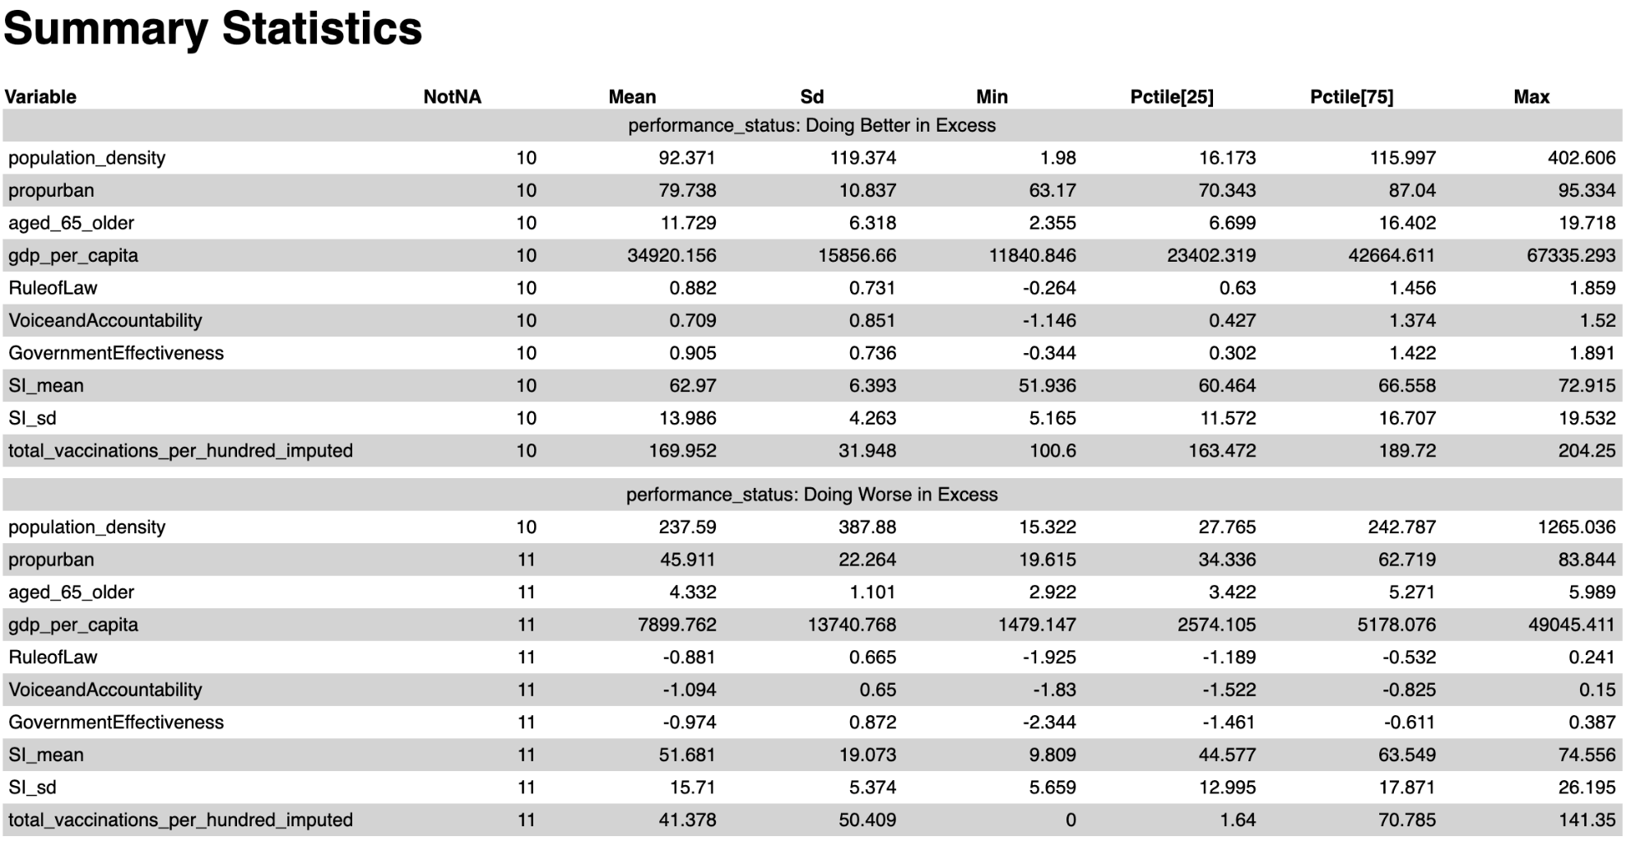

Table 9: Correlation Matrix
 | SI  (mean) | SI  (SD) | Vaccinations | Population Density | Urban Population Share | Aged 65+ Population Share | GDP per capita | Rule of Law | Voice & Accountability | Government Effectiveness
Average SI | 1.00 | -0.10 | 0.41 | 0.02 | 0.27 | 0.07 | 0.18 | 0.08 | 0.06 | 0.14
SD of SI | -0.10 | 1.00 | -0.07 | -0.13 | -0.03 | -0.05 | -0.09 | -0.06 | 0.05 | -0.13
Vaccinations | 0.41 | -0.07 | 1.00 | 0.18 | 0.59 | 0.56 | 0.67 | 0.66 | 0.47 | 0.71
Population Density | 0.02 | -0.13 | 0.18 | 1.00 | 0.21 | 0.10 | 0.34 | 0.25 | 0.00 | 0.27
Urban Population Share | 0.27 | -0.03 | 0.59 | 0.21 | 1.00 | 0.47 | 0.67 | 0.52 | 0.39 | 0.53
Aged 65+ Population Share | 0.07 | -0.05 | 0.56 | 0.10 | 0.47 | 1.00 | 0.51 | 0.70 | 0.72 | 0.71
GDP per capita | 0.18 | -0.09 | 0.67 | 0.34 | 0.67 | 0.51 | 1.00 | 0.76 | 0.41 | 0.75
Rule of Law | 0.08 | -0.06 | 0.66 | 0.25 | 0.52 | 0.70 | 0.76 | 1.00 | 0.76 | 0.95
Voice and Accountability | 0.06 | 0.05 | 0.47 | 0.00 | 0.39 | 0.72 | 0.41 | 0.76 | 1.00 | 0.72
Government Effectiveness | 0.14 | -0.13 | 0.71 | 0.27 | 0.53 | 0.71 | 0.75 | 0.95 | 0.72 | 1.00
Note: SI is the Government Response Stringeny Index, Vaccinations is the number of Covid-19 vaccines administered per hundred population.

References
Acemoglu, D., Chernozhukov, V., Werning, I., & Whinston, M. D. (2021). Optimal targeted lockdowns in a multigroup SIR model. American Economic Review: Insights, 3(4), 487-502.
Aizenman, J., Cukierman, A., Jinjarak, Y., & Xin, W. (2021). International Evidence on Vaccines and the Mortality to Infections Ratio. National Bureau of Economic Research, NBER Working papers No. w29498.
Data on COVID-19 (coronavirus) by Our World in Data, https://github.com/owid/covid-19-data/tree/master/public/data
Karlinsky, A., & Kobak, D. (2021). Tracking excess mortality across countries during the COVID-19 pandemic with the World Mortality Dataset. Elife, 10, e69336.
Kendall DG (1956). "Deterministic and stochastic epidemics in closed populations". Proceedings of the Third Berkeley Symposium on Mathematical Statistics and Probability: Contributions to Biology and Problems of Health. 4: 149–165
Kermack, William Ogilvy, A. G. McKendrick, and Gilbert Thomas Walker, (1927). “A contribution to the mathematical theory of epidemics,” Proceedings of the Royal Society of London. Series A, Containing Papers of a Mathematical and Physical Character, 115 (772), 700–721.
Mathieu, E., Ritchie, H., Ortiz-Ospina, E. et al. A global database of COVID-19 vaccinations. Nat Hum Behav (2021). https://doi.org/10.1038/s41562-021-01122-8
The Economist's tracker for covid-19 excess deaths. https://github.com/TheEconomist/covid-19-excess-deaths-tracker
Thomas Hale, Noam Angrist, Rafael Goldszmidt, Beatriz Kira, Anna Petherick, Toby Phillips, Samuel Webster, Emily Cameron-Blake, Laura Hallas, Saptarshi Majumdar, and Helen Tatlow. (2021). “A global panel database of pandemic policies (Oxford COVID-19 Government Response Tracker).” Nature Human Behaviour. https://doi.org/10.1038/s41562-021-01079-8

See the Economist article “There have been 7m-13m excess deaths worldwide during the pandemic”, and Kalinsky and Kobak (2021).
We focus on contrasting countries with movements by at least two quartiles ranked by official and excess mortality and thus do not include countries with only one-quatile movements because small quartile movements (e.g., one quartile) could be results from those large movements (e.g., at least two quartiles) rather fundamental difference in their morality between official and excess measures.

